TidyTowns Special Awards 2024
The RIAI Town Challenge

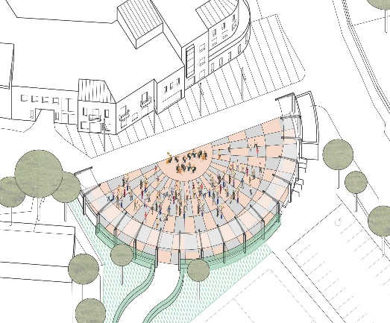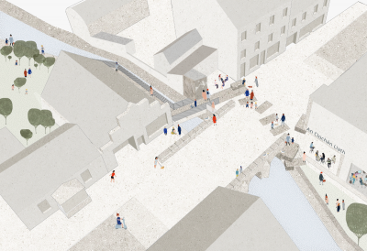
Left: Urban Design Vision for Oranmore TidyTowns Committee by Louise Cotter MRIAI, Cotter & Naessens Architects
Right: Urban Design Vision for Dungloe TidyTowns Committee by Pasparakis Friel Architects

The RIAI Town Challenge is a Special Award, designed to give a TidyTowns Committee practical support in form of architectural expertise in addressing a public realm problem in your town.
If your town has difficulties for example with derelict sites, signage, lack of public space, traffic or parking issues, this RIAI Award will give you the opportunity to work with a Registered Architect to develop a vision for an urban design solution that can help solve a problem and enhance your town. Registered Architects are trained to develop and deliver solutions for our built environment.

The RIAI Town Challenge Special Award will provide the winning TidyTowns Committee with the expertise of a Registered Architect for up to 5 days and to a value of €5,000.

About the Award
The Royal Institute of the Architects of Ireland (RIAI) is providing the services of a Registered Architect to work with a local TidyTowns Committee to prepare a high-level urban design ‘vision’ to help solve a problem in your town. The award consists of an architectural commission.

The commissioned Registered Architect will provide an analysis of the problem as initially identified by the local TidyTowns Committee, in addition to developing a concept/vision to address it. The commission will result in an illustrated Report, which will be made publicly available and a presentation to the local TidyTowns Committee.

Award Value
This is an RIAI sponsored Special Award to promote good urban design in Irish towns. The award consists of an architectural commission to the value of €5,000.

Who Can Apply
This competition is open to the Small Towns and Large Towns categories.

How to Apply
In order to apply, the local TidyTowns committee will complete the entry form, including a short paragraph which identifies the positive characteristics of the town, as well as its problems.
This should be supported with photographs.

Please reply by completing this document and returning it with the photographs by email to communications@riai.ie, subject line: RIAI Town Challenge Award 2024

Closing Date
Wednesday 5 June. Please check the TidyTowns’ website www.tidytowns.ie for updates.

Judging the Award
All entries will be assessed by an RIAI jury. TidyTowns’ Competition Terms and Conditions apply as appropriate.

Useful References

https://www.riai.ie/whats-on/news/creating_places_for_people_riai_town_and_village_toolkit
https://www.heritagecouncil.ie/content/files/Ballybrilliant.pdf
https://www.heritagecouncil.ie/advice-and-guidance/renewing-your-historic-town-or-village
https://www.heritagecouncil.ie/ga/projects/podcast-series-putting-town-centres-first

Application Form for the TidyTowns RIAI Town Challenge 2023
Name of Tidy Town or community group Main contact person’s name

Email: Phone No :

Postal Address:

- What opportunities do you see for improvement in your town?

- What problems relating to public realm and the built environment are evident
in your town?

- Are there any Local Area, Development or other Plans in place for your town?

4. Are there any traffic management and parking control plans in your town?

Please submit your description on one A4 page (please note that additional text will not be considered) and include photographs or video to illustrate your description.

