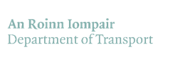 [](https://www.google.ie/url?sa=i&rct=j&q=&esrc=s&source=images&cd=&cad=rja&uact=8&ved=0ahUKEwjG3deeu4PSAhUoCMAKHZxIBY4QjRwIBQ&url=https://en.wikipedia.org/wiki/Tidy_Towns_(Ireland)&psig=AFQjCNE6O_QytkIIdIgH2gUTjT--tKZVsw&ust=1486745102083734)

Greenways and Active Travel Special Category Award

Tidy Towns Competition 2025

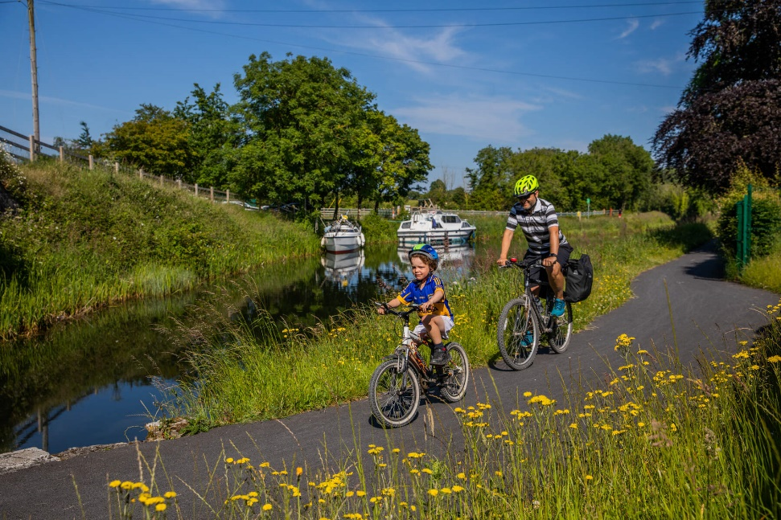

*Community groups can play a vital role in showcasing our Greenway and Active Travel Projects. Together, we can protect our greenways and active travel projects for future generations to enjoy.*

This competition is open to Community Groups who have shown an appreciation for their Greenway / Active Travel project by undertaking relevant initiatives or projects.

**Greenways and Active Travel Special Category Award Prize Fund 2025**

**Overall Prize Fund of €5,000**

**To be split equally between Greenways and Active Travel initiatives**

The Greenways and Active Travel Special Category Award is run in conjunction with the SuperValu Tidy Towns competition which this year celebrates its 67th years of encouraging and rewarding community effort.

**The closing date for SuperValu Tidy Towns special category awards is 9th June 2025.**

**Background to the Award**

The Department of Transport is delighted to sponsor two new special category awards, one for Greenway projects and another for Active Travel Projects this year. In recent years, there has been a significant increase in investment in active travel and greenway infrastructure with the Government of Ireland committed to spending €360M in 2025. In 2024, 64km of Greenway and 184km of Active Travel infrastructure was delivered. The provision of walking and cycling facilities in our cities, towns and villages is critical in providing safe and accessible transport corridors connecting our urban centres for pedestrians and cyclists. This infrastructure are public assets designed for use by members of the public to undertake trips for a range of purposes – recreational, commuting, travelling to school and undertaking errands

In addition, they support positive economic, social and health outcomes in local communities. These routes can offer an opportunity to the local community to showcase the beauty of their local area through their stewardship endeavours. These can range from modest interventions to more ambitious plans – examples could include organised litter picks, planting of native woodland species, painting of murals, public art, installing bird boxes, use of recycling materials, committing to a pollinator friendly planting scheme etc. This special category primarily seeks to recognise the efforts of tidy town committees in relation to integrating built infrastructure with ecological best practices as well as enriching local community assets. Aside from infrastructure, initiatives such as school bike buses and bike libraries can also be submitted for consideration.

Some images are provided on pages 2 and 3 for demonstrative purposes.

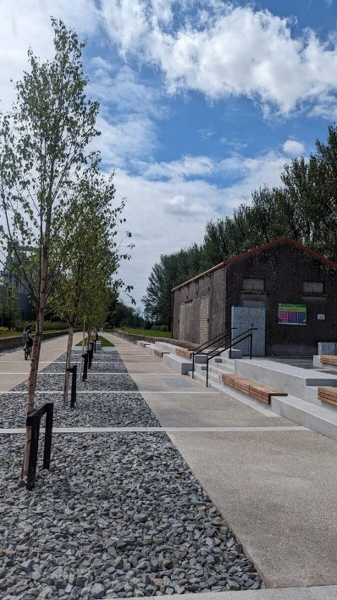 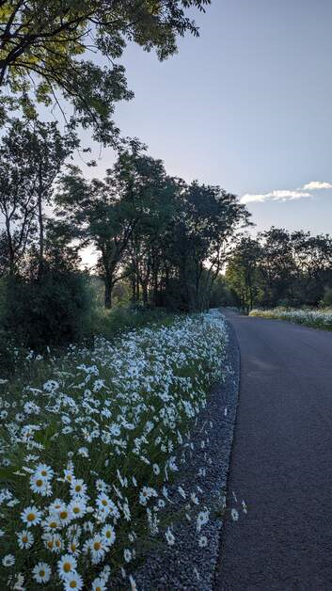 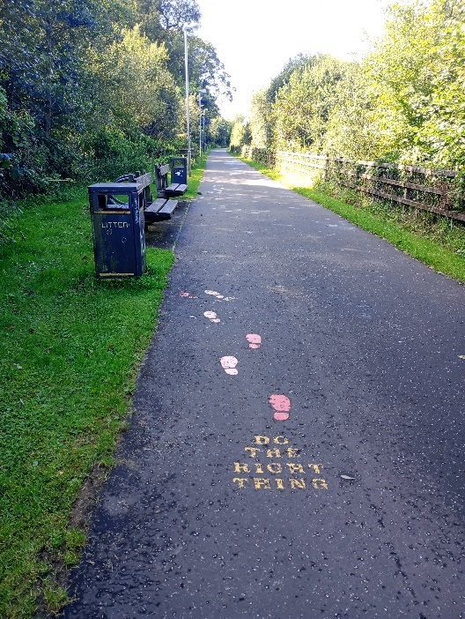

Midleton to Youghal Greenway, County Cork Strathfoyle Greenway, County Derry

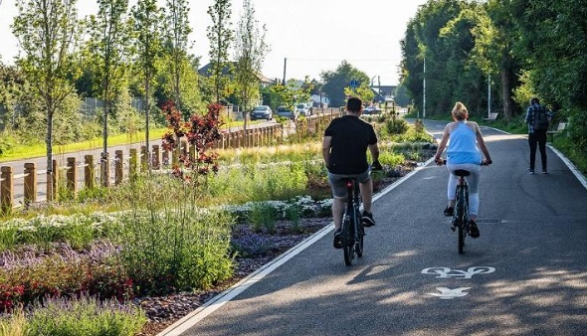 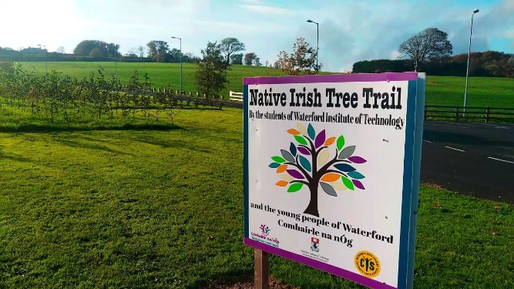

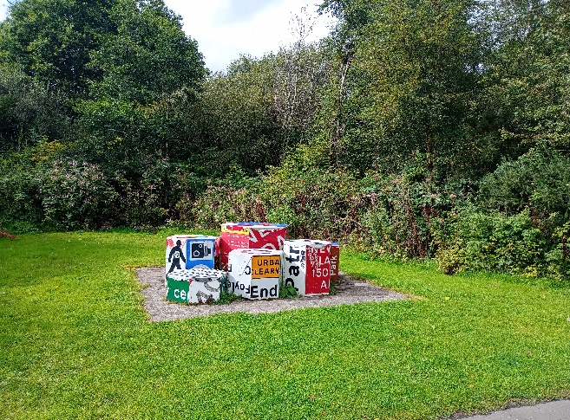Glouthane, County Cork Tree Trail - WIT, County Waterford

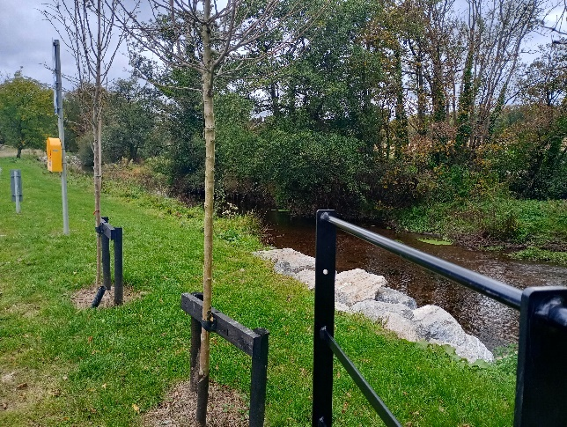

Midleton to Youghal Greenway, County Cork Strathfoyle Greenway, County Derry

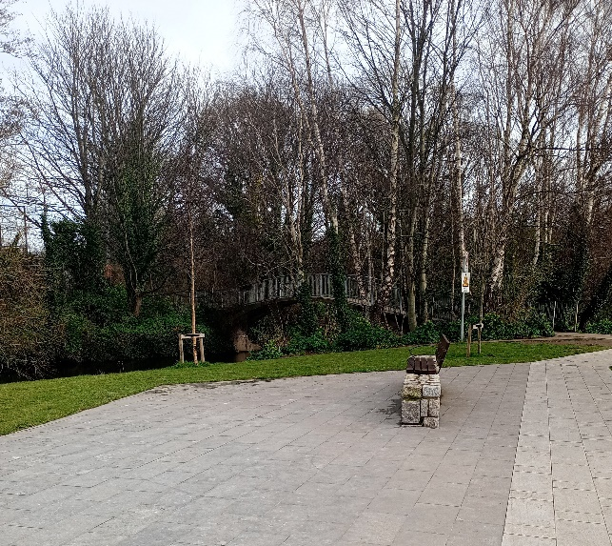 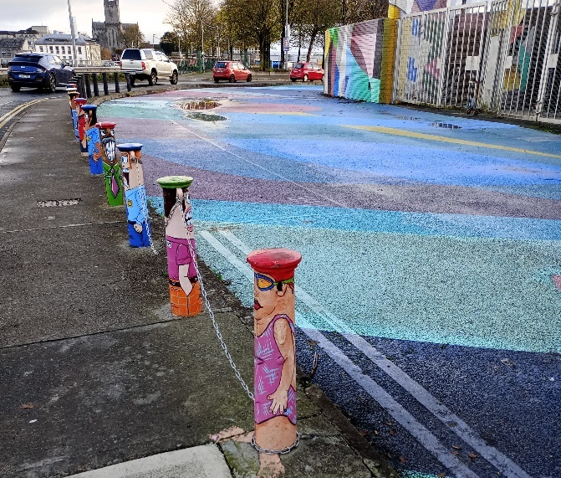

Dodder Greenway, County Dublin Limerick City

**Category Definitions**

Greenways refer to segregated routes that can be used by pedestrians, wheelchair users, children in buggies as well as people on all types of bicycles. They are designed to meet the requirements of all users in terms of avoiding steep gradients, providing a good surface condition and a minimum route corridor width to provide for adequate space for all uses. Greenway are generally scenic routes that showcase the beauty of the surrounding landscape to users. Greenway project submissions are limited to the immediate vicinity of a greenway route as it approaches the urban environment (typically within 2km of the urban limit). Accordingly, maps of your town/ village (required for the main competition submission) should also be submitted with the application form for this special category award. It is intended that the adjudicators will use these maps to ensure that the submitted projects within the immediate vicinity of the town / village limits. These boundaries are generally marked by the 50/30km speed limit - flexibility by the adjudicators may be applied to submissions as this is the first year of this award.

Active Travel infrastructure refers to a range of walking and cycling schemes generally within the urban environment which include improved pedestrian environments, new segregated cycling lanes, pedestrian and cycling bridges and pedestrian crossings. A specific example would be the Safe Routes to School (SRTS) Programme which aims to encourage walking, scooting, and cycling to primary and post-primary schools by creating safer walking and cycling routes and alleviating congestion at school gates and increase the number of students who walk or cycle to school. The Department of Transport also facilitates, supports and encourages other initiatives including Bike Week and the Smarter Travel Mark schemes to encourage walking, cycling, public transport usage and carpooling on the commute and beyond while reducing carbon emissions.

|  |
| --- |
| **Application Form for the Tidy Towns Greenway and Active Travel special category awards 2025**  Name of TidyTown or other community group Main contact person’s name  Email: Phone:  Postal Address:  **Please select category application relates to ‘Greenway’  OR ‘Active Travel’ .** |
| 1. **Awareness Raising (15 Marks)**   Demonstrate how your community group has helped raised awareness of your initiative (examples could include organised litter picking days, planting of native woodland species, rewilding initiatives, mural painting, installation of benches, bird boxes etc.).  Demonstrate how these efforts have promoted these routes beyond being transport corridors but representing a sustainable asset that can be enjoyed by all members of the community. - *Max 250 words.* |
| 1. **Community Involvement (20 Marks)**   Please outline how your initiative involved the wider community.  (e.g. did you work with schools, landowners or other groups?).  *Max 250 words.* |
| 1. **Stakeholder Engagement (15 Marks)**   Please outline any efforts made in relation to engaging with your Local Authority or Local Development Company, other public agencies and other relevant stakeholders in developing the initiative.  *Max 250 words.* |
| 1. **Project Benefits (40 Marks)**   Please outline the long-term benefits of your initiative to the environment and local community.  *Max 250 words.* |
| 1. **Lessons Learned (10 marks)**   Please provide details of the lessons you have learned from the Greenway / Active Travel project and how you will incorporate these into you plans for future projects on the greenways / active travel network  *Max 250 words.* |

*Photographs to accompany your application are encouraged.*

*Submissions must include a map of the individual town/ village* *showing the Town/Village limits (this is generally within the 50/30km speed limit).*

**Judging the Award**

All entries will be assessed by a panel of judges appointed by the Department of Transport, Transport Infrastructure Ireland and the National Transport Authority. The panel of judges reserve the right to contact you to clarify any details submitted.

|  |  |
| --- | --- |
| How to Apply: | Please submit a good quality map of your town/village with the project clearly marked. Please reply by completing all sections of this application form and return by email to the email address below. below. |
| Email: Greenways@transport.gov.ie | Please insert ‘Super Valu TidyTowns Greenway and Active Travel Special Category Awards’ in the subject line. |
|  |  |

*Tidy Towns Competition Terms and Conditions apply as appropriate.*

**Closing date: 9th June 2025.**

[](https://www.google.ie/url?sa=i&rct=j&q=&esrc=s&source=images&cd=&cad=rja&uact=8&ved=0ahUKEwjG3deeu4PSAhUoCMAKHZxIBY4QjRwIBQ&url=https://en.wikipedia.org/wiki/Tidy_Towns_(Ireland)&psig=AFQjCNE6O_QytkIIdIgH2gUTjT--tKZVsw&ust=1486745102083734)